Atom?

Atoms are defined as ***“the basic building blocks of matter”***.

It is the smallest constituent unit of matter that possess the properties of the chemical element. Atoms don’t exist independently, instead, they form ions and molecules which further combine in large numbers to form matter that we see, feel and touch.

Atoms and Molecules Definition

Atoms are much too small to be seen; hence experiments to find out their structure and behavior have to be conducted with large numbers of them. From the results of these experiments we may attempt to construct a hypothetical model of an atom that behaves like the true atom.

Molecules consist of one or more atoms bound together by covalent (chemical) bonds. Atoms may be depicted by circle shapes, each of which has a nucleus at the center (containing protons and neutrons), surrounded by one or more concentric circles representing the ‘shells’ or ‘levels’ in which the electrons surrounding the nucleus of the atom are located and markings indicating the electron.at each level. A molecule is the smallest thing a substance can be divided into while remaining the same substance. It is made up of two or more atoms that are bound together by chemical bonding.

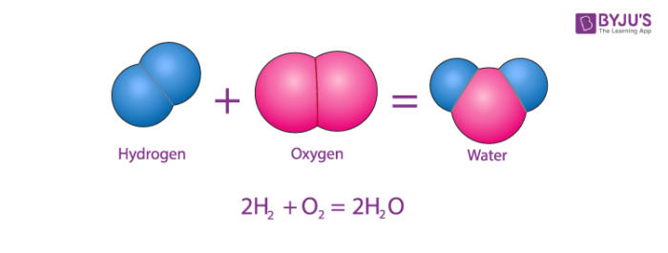

Atom :A closer look

The smallest particle of an element, which may or may not have an independent existence but always takes place in a chemical reaction is called an atom. An atom is defined as the smallest unit that retains the properties of an element. An atom is composed of sub-atomic particles and these cannot be made or destroyed. All atoms of the same element are identical and different elements have different types of atoms. Chemical reactions occur when atoms are rearranged.

Atoms consist of three fundamental types of particles, protons, electrons and neutrons. Neutrons and protons have approximately the same mass and in contrast to this the mass of an electron is negligible. A proton carries a positive charge, a neutron has no charge and an electron is negatively charged. An atom contains equal numbers of [protons](https://byjus.com/chemistry/protons/) and electrons and therefore overall an atom has no charge. The nucleus of an atom contains protons and neutrons only, and therefore is positively charged. The electrons occupy the region of space around the nucleus. Therefore, most of the mass is concentrated within the nucleus.

The center of the atom is called the nucleus. The nucleus contains neutrons and protons that give an atom its weight and positive charges. A neutron carries no charge and has a mass of one unit. A proton carries a single positive charge and also has a mass of one unit, The atomic number of an element is equal to the number of protons or positive charges in the nucleus. The atomic weight of an element is determined by combining the total number of protons and neutrons in the nucleus. An electron carries a single negative charge. If an atom of an element is to have zero charge, it must have the same number of electrons as protons. These electrons are arranged in orbits around the nucleus of the atom like the layers of an anion.

What are Atoms made of?

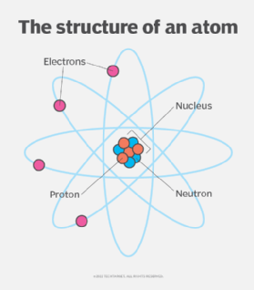

An atom is composed of three particles, namely,  ***neutrons, protons and electrons*** with hydrogen as an exception without neutrons.

* Every atom has a nucleus that bounds one or more electrons around it.
* The nucleus has typically a similar number of protons and neutrons which are together known as nucleons.
* The protons are positively charged, electrons are negatively charged and neutrons are neutral.

What is Atomic Mass?

It is the mass of an atom in a chemical element. It is roughly equivalent to the total [neutrons and protons](https://byjus.com/chemistry/proton-neutron-discovery/) present in the atom. It is expressed in atomic mass units (denoted by u). 1amu is equal to the exactly one-twelfth of the mass of 1 atom of C-12 and the relative atomic masses of elements is determined with respect to-12 atom.

Atomic masses of Some Elements

|  |  |
| --- | --- |
| **Elements** | **Atomic Mass (u)** |
| Hydrogen | 1 |
| Carbon | 12 |
| Nitrogen | 14 |
| Oxygen | 16 |
| Sodium | 23 |
| Magnesium | 24 |
| Sulfur | 32 |
| Chlorine | 35.5 |
| Calcium | 40 |

Salient features of Dalton’s Atomic Theory

* The matter is composed of minute particles known as atoms.
* Atoms are indivisible particles that can’t be destroyed or created through [chemical reactions](https://byjus.com/chemistry/chemical-reactions/).
* All atoms of an element have identical chemical properties and mass whereas, atoms of different elements have different chemical properties and masses.
* Atoms combine in a ratio of small whole numbers to form compounds.

The matter is anything and everything in our surrounding. It has basic structural and fundamental units. Let us examine the concept of matter with an example. Taking a storybook into consideration and dividing its structure. The book contains many pages, each page consists of paragraphs, and each paragraph has many sentences.

Each sentence will further have many words and each word will have characters. Therefore we have divided a storybook into characters. This is exactly the same case when we take the matter into account. The matter is made up of substances which contain molecules. The molecules, in turn, are made up of groups of atoms.

Atoms in simple terms are defined as the smallest unit of matter. In ancient times scientists wondered whether the matter could be further divided or not

What is a Molecule?

Molecule Definition

A molecule is defined as the smallest unit of a compound that contains the chemical properties of the compound.

Molecules are made up of groups of atoms. Describing the structure of an atom, an atom is also sub-divided into smaller units. Protons, electrons, and neutrons are sub-particles of an atom. The protons and neutrons are contained inside the nucleus of the atom and electrons revolve around the nucleus.

Protons are positively charged particles whereas electrons are negatively charged particles. Neutrons do not carry any charge. So we can say that the nucleus is positively charged due to the presence of protons. The nucleus is a bulk mass at the centre of an atom. Atoms are largely vacant.

Every element has a certain atomic number. The atomic number of an element is defined as the number of protons present in its nucleus. It is denoted by Z.

When we talk about the mass of atoms, the mass of their particles is taken into consideration. Electrons have negligible mass. Hence the mass of an atom is the sum of the mass of protons and neutrons. The mass number is denoted by A.

A molecule is the smallest unit (particle) of a compound having the physical and chemical properties of that compound. This does not mean that molecules can not be broken down into smaller parts, e.g. the atoms from which they are formed or the fragments of the molecule, each consisting of several atoms or parts of atoms.

A molecule is defined as the smallest unit of a compound that contains the chemical properties of the compound. Molecules are made up of groups of atoms. Describing the [structure of an atom](https://byjus.com/jee/atomic-structure/), an atom is also sub-divided into smaller units. Proton, electrons, and neutrons are sub-particles of an atom. The protons and neutrons are contained inside the nucleus of the atom and electrons revolve around the nucleus.

Examples of Molecules

A molecule is a collection of two or more atoms that make up the smallest recognisable unit into which a pure material may be split while maintaining its makeup and chemical characteristics. Some examples of molecules are

* H2O (water)
* N2 (nitrogen)
* O3 (ozone)
* CaO (calcium oxide)
* C6H12O6 (glucose, a type of sugar)
* NaCl (table salt)

Forces between Atoms and Molecules

The simplest forces between atoms are those which arise as a result of electron transfer. A simple example is that of say sodium fluoride. The sodium atom has a nuclear charge of +11, with 2 electrons in the K shell, 8 in the L shell and 1 in the M shell. The fluorine atom has a nuclear charge of 9 with 2 electrons in the K shell and 7 in the L shell.

The outermost electron in the sodium atom may transfer readily to the fluorine atom; both atoms then have a complete shell but the sodium now has a net charge of +1 and the fluorine a net charge of -1. These ions, therefore, attract one another by direct coulombic interaction. The force between them is strong it varies as x-2, where x is the distance between the ions, and it acts in the direction of the line joining the ions.

# TYPES OF MOLECULES

If the molecule of an element contains 1 atom it's called a monoatomic molecule.  
E.g. Na, He, etc.

If the molecule of an element contains 2 atoms it's called a diatomic molecule.  
E.g. O2, N2

If the molecule of an element contains more than 2 atoms it's called a polyatomic molecule.  
E.g. P4, S8

Elements and compounds are the two forms in which pure substances exist.

Element Definition:

**Elements –** Elements constitute the simplest chemical substances in which all the atoms are exactly the same.

Compound Definition:

**Compounds –** Compounds are chemical substances made up of two or more elements that are chemically bound together in a fixed ratio.

Chemistry is the study of the structures, physical properties, and chemical properties of material substances. It is very important to understand that all gases, liquids and solids are not the same. All are different in terms of their composition. This is the reason why the classification of the matter is very important.

Classification of Matter

1. *Elements*
2. *Compounds*
3. *Mixtures*

Here we are going to discuss two categories of the matter: **Elements and Compounds**

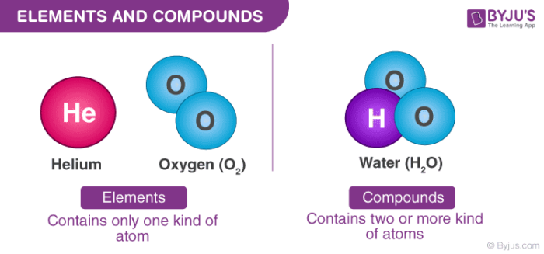

What is a Compound?

***When two or more elements chemically combine in a fixed ratio by mass, the obtained product is known as a compound.*** Compounds can be defined as substances consisting of 2 or more different types of elements in a fixed ratio of their atoms. When the elements combine, some individual property of the elements is lost and the newly formed compound has new properties.

***Chemical Formula:***Compounds are represented by their chemical formula. A chemical formula is a symbolic representation of the proportions of atoms that constitute a particular chemical compound.

The chemical formula of water is H2O which shows two atoms of hydrogen and one atom of [oxygen](https://byjus.com/chemistry/oxygen/) have combined to form one molecule of H2O. The chemical formula for common salt is NaCl which shows one atom of sodium and one atom of chlorine combine to form one molecule of NaCl.

1. Types Of Compounds

Compounds can be classified into two types, molecular compounds and salts. In molecular compounds, the atom binds each other through covalent bonds. In salts, it is held together with ionic bonds. These are the two types of bonds out of which every compound is made of.

2. Example Of Compounds

* Example of compounds includes water (H2O), [Hydrogen Peroxide](https://byjus.com/jee/hydrogen-peroxide-properties-preparation/) (H2O2), etc. You could see water’s chemical formula, it says it has 2 atoms of Hydrogen combined with 1 atom of oxygen and in hydrogen peroxide, it has 2 atoms of hydrogen and two atoms of oxygen.
* Similarly,  an example of salt would be the table salt (NaCl) which has 1 atom of sodium and one atom of chlorine.

Examples of some commonly used compounds and their molecular formula:

|  |  |
| --- | --- |
| **Compound Name** | **Compound Formula** |
| Alcohol | C2H6O |
| Acetic Acid | C2H4O2 |
| Sulphuric Acid | H2SO4 |
| Ammonia | NH3 |
| Methane | CH4 |
| Nitrous oxide | N2O |
| Salt | NaCl |

What are the Elements?

We can define elements as a ***species of atoms that have the same number of protons in their atomic nuclei.*** Although an element’s atoms have the same number of protons, they can have different numbers of neutrons and hence different masses.

***Isotopes:*** When atoms of the same element have different numbers of neutrons, they are known as isotopes. As of now, there are 118 elements, of which the first 94 are naturally occurring while the remaining 24 are synthetic elements.

Elements are complete chemical substances which relate to a single entry in the modern periodic table. Elements consist of one kind of atom only. They cannot be broken down into simpler fragments and can exist as atoms or as molecules. Elements are represented by symbols that are assigned by IUPAC. For example, Oxygen is represented by O, Aluminium is represented by Al, etc.

1. Types of Elements

The elements are arranged in the periodic table and are split depending upon their groups as either metallic or non-metallic. Metallic is further classified into Main Group Metals, Transition Metals, and f-block metals. These are again further divided, depending upon their properties.

2. Examples of Elements

Elements exist in their simplest form and cannot be broken down further. So, elements can exist in the form of ions, atoms, isotopes, molecules.

* An example of an element is Nitrogen atom(N), Nitrogen gas (N2), Nitrogen ion(N3–) and Nitrogen isotopes (Nitrogen-13, Nitrogen-14, and Nitrogen-15).

Similarly, you could see other elements’ existence.

Examples of some commonly used elements along with their chemical symbols:

|  |  |
| --- | --- |
| **Name of the element** | **Chemical symbol** |
| Hydrogen | (H) |
| Boron | (B) |
| Carbon | (C) |
| Silicon | (Si) |
| Sodium | (Na) |
| Lead | (Pb) |
| Platinum | (Pt) |

**Difference Between Element and Compound**

|  |  |  |  |
| --- | --- | --- | --- |
| **Sl. No.** | **Differentiating Property** | **Element** | **Compound** |
| 1 | Definition | Elements are pure substances which are composed of only one type of atom. | Compound are substances which are formed by two or more different types of elements that are united chemically in fixed proportions. |
| 2 | Total Numbers | There are nearly 118 elements (at present) of which nearly 94 occur naturally on Earth. | Compounds are almost endless. |
| 3 | Types | Elements are classified as either metals, nonmetals or metalloids. | Compounds are classified according to their bonds which can be ionic, molecular or metallic. |
| 4 | Examples | Some of the examples of elements are Iron, Copper, Gold, etc. | A few examples of compounds are NaOH, NaCl, etc. |
| 5 | Representation | Elements are represented by symbols and numbers. For example, Sodium is represented by Na. | Compounds are represented by their chemical formula. For example, salt is represented by the formula NaCl. |
| 6 | Distinguished By | Elements can be distinguished by their atomic number. | Distinguished by their fixed ratio of different elements (arranged in a defined manner). |
| 7 | Composition and Property | As only one type of atoms makes up an element, all the properties of that atom are represented by its atom. | In the case of compounds, the same type of molecules makes up the compound. |
| 8 | Ability to Breakdown | Elements cannot be broken down by chemical reactions. | Compounds can be easily separated into simpler substances by chemical reactions. |

These were a few main differences between element and compound. These element and compound differences in tabular form can help the students to easily understand the underlying concepts and students can easily retain the points for longer

**What is the Main Difference between Atom and Molecule?**

The difference between an atom and a molecule is explained below:

|  |  |
| --- | --- |
| **Atom** | **Molecule** |
| They are minute fragments of an element, which may or may not exist naturally. | A collection of atoms joined by a bond is referred to as a molecule. |
| They might or might not be free to exist. | They live in a state of independence. |
| It is made of an electron and a nucleus (proton and neutron). | It consists of two or more bonded parts, which could be distinct or similar. |
| They are spherical in form. | They are angular, triangular, or linear in form. |
| Not apparent to the bare eyes or a powerful microscope. | Not visible to the human eye but are detectable under a microscope. |
| They react quickly and are susceptible to some outliers. | It is less reactive in comparison. |
| A nuclear bond connects it. | There is a covalent bond formation. |

# Chemical Bonding

Chemical bonding is essential in creating different molecules**.** As discussed in

the first chapter, a molecule is a result of two or more elements bonded

chemically. A molecule makes up different kinds of matter, depending on the

number of elements used and the way they were bonded.

But, why do elements need to bind?

The elements need to bind with each other to stabilize the molecule of a

compound. Each atomic structure of a molecule must have a stable valence

shell. A valence shell is considered stable if it has 8 valence electrons.

Let us use the atomic structure of Potassium to illustrate.

Potassium has a nucleus with 19 protons and 20 neutrons. It has a first shell

with 2 electrons, a second shell with 8 electrons, a third shell with 8 electrons

and an outer shell with only 1 valence electron.

The first and the second shells of potassium are considered stable because

they were completely filled. The third shell cannot be considered stable

because it only has 8 electrons. The problem is in the last shell. It only has 1

valence electron.

The potassium element needs to stabilize its atom to create a stable molecule.

It can be stable if it would give up its valence electron to another element.

Therefore, the potassium will now lose its fourth shell. However, the third

shell would now become its new outer shell. Since the third shell has 8

electrons, the new outer shell is deemed stable.

In some cases, an element could stabilize its atom by sharing some of its

electron with another element.

**Electrovalent/ ionic bonding**  
This involves transfer of electrons from a metal to a non metal. The number of electrons lost by the metal atom or gained by non metal atom is equivalent to its valency. The loss of electrons from a metal atom leads to formation of a positively charged ion (cation) and the gain of electrons by a non metal atom leads to the formation of a negatively charged ion (anion). The positively charged ion and the negatively charged ion are attracted to each other and the force of attraction holding them together is known as electrovalent/ionic bond. The compounds formed are referred to as ionic/ electrovalent compounds. Metal atoms lose electrons so as to gain stable electronic configuration of noble gases and non metal atoms also gain electrons to become stable.

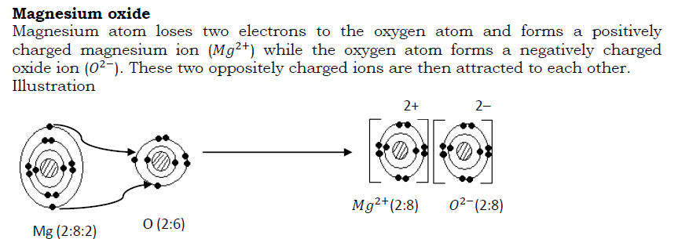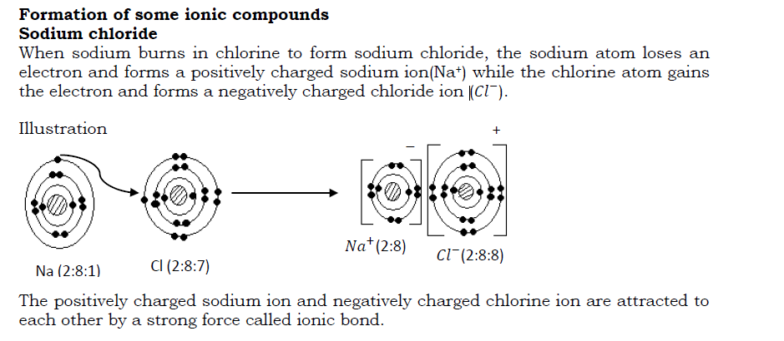

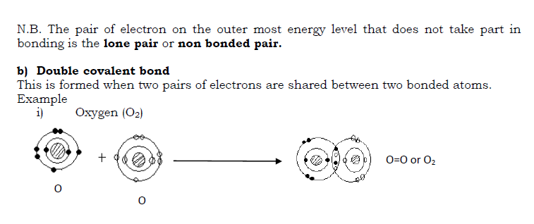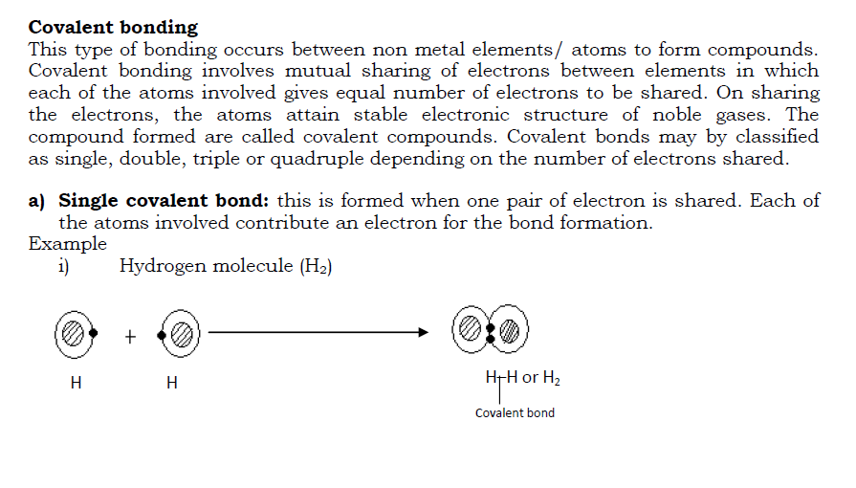

Dative/ co-ordinate bond  
This involves sharing of electrons but the shared pair of electrons is donated by one atom/ molecule. Here, one molecule/ atom donates the pair of electrons to be shared with an ion or another atom. Normally it is atoms/ molecules with lone pair of electrons that form this bond-by donating the lone pair of electrons to be shared with another atom/ion. The bond may be represented by an arrow originating from the donor atom (atom that donates electrons to be shared) to the atom accepting the electrons.

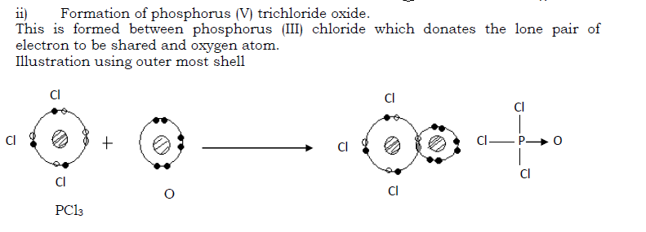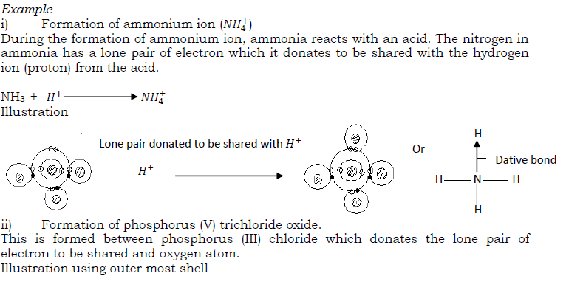

Metallic bonding  
This is the type of bonding in metals due to the attraction between metal ions and the valency electrons within the structure of the metal (metal lattice). In the structure of a metal, the loosely held valency electrons (electrons in the outer mos energy level) are released in to a general pool and the atoms become positively charged. These electrons move freely around the ions formed and are termed as mobile/delocalized electrons.

The ions formed and the electrons attract each other forming metallic bond.  
The strength of metallic bond increases with increase in the number of electrons released in to the electron cloud. Thus the bond is very strong in metals like iron and aluminum that release up to three electrons each to the electron pool and weak in metals like sodium and potassium that only release one electron each to the electron pool.

Illustration

Each sodium ion is surrounded by six chloride ions and each chloride ion is also surrounded by six sodium ions. The co-ordination number is there fore 6:6.

**Properties of ionic compounds**

1. They are solids with a regular shape. This is because of the strong electrostatic forces of attraction keeping the ions closely packed.
2. They have high melting points. This is due to the strong electrostatic force af attraction between oppositely charged ions.
3. They do not conduct electricity in solid states but do conduct in their molten states or solution form. This is because in solid states, the ions are localized and the electrons are not mobile but in molten form, the ions and electrons are free to move (electrons become delocalized) and thus conduct electricity.
4. They have high density as the ions are closely packed.
5. Ionic compounds are soluble in water and other polar solvents but they are insoluble in organic solvents like benzene. Ionic compounds dissolve in polar solvents like water as the ions are attracted by the polar molecule.  
   A polar compound is a covalent compound in which charge separation exist between atoms. This is due to the differences in electro negativity between the atoms.  
   Electro negativity is the tendency of an atom to attract bonding electron towards itself. Electro positivity is the tendency of an atom to push away bonding electrons from itself.  
   For example, in a water molecule oxygen is more electro negative and attracts the bonding electrons towards itself giving it a partial negative charge. Hydrogen attains a partial positive charge.  
   Structure of a water molecule

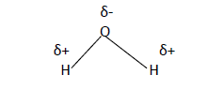

**NB** Most metals are malleable and ductile. This is because, since the bonding agent in a metal is a moving electron cloud, the ions of the metal; usually slide relative to one another under stress (without shattering the lattice and produce a new position of stability).

Simple molecular structures  
The structure consists of simple independent molecules joined together by weak intermolecular forces of attraction. E.g. Vander Waal‘s force of attraction. The atoms in the molecule are held together by strong covalent bond. Compounds with this structure exist as gases, liquids or solids with low melting points. Examples include iodine, carbon dioxide , ammonia and water.

Structure of iodine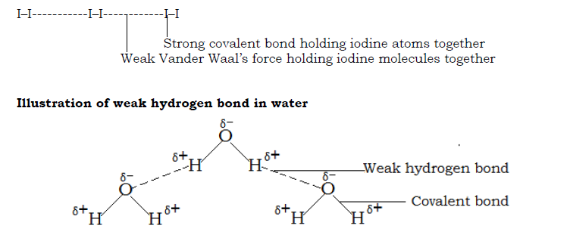

Properties of simple molecular structures

* They have low melting and boiling points because the molecules are held by weak intermolecular forces of attraction.
* They are non conductors of electricity because they do not have mobile electrons/ ions.
* Most of them are gases and liquids. Very few are solids.
* They have low densities as the molecules are not closely packed.
* They dissolve in organic solvents.

Giant atomic/molecular structure  
Compounds with such structures consist of molecules /atoms linked together by strong covalent bonds resulting into a giant three dimensional or three dimensional structures like in graphite and diamond respectively (see details under Carbon and its compounds)  
Properties of giant molecular structures

* They have high melting and boiling pints because of great energy needed to break the bonds.
* They do not conduct electricity except graphite which has delocalized electrons.
* They are insoluble in water.

Giant metallic structure  
Giant metallic structure consists of very many metal ions surrounded by a sea /cloud of electrons. These electrons are released by metal atoms.  
Properties of giant metallic structures

* They are solids with high melting and boiling points except mercury which is a liquid.
* They conduct electricity in both liquid and solid states due to the presence of mobile electrons.

# Introduction to alloys

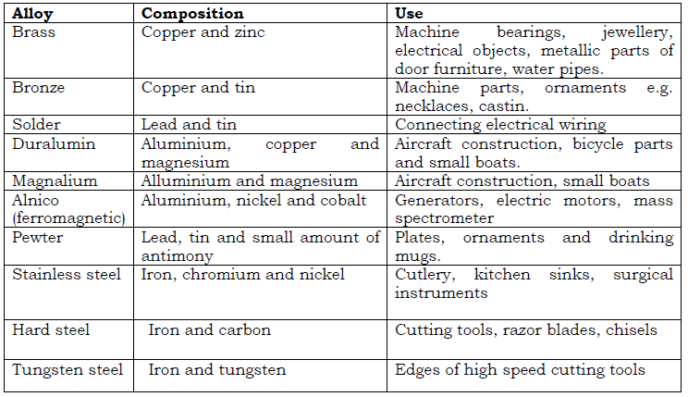An alloy is a mixture of two or more metals. Alloys are formed by thoroughly mixing molten metals. It has been found that alloying produces metallic substance with more useful properties than the original pure metal it is made from. Examples of alloys include

**Simple Criteria for purity**  
A pure substance is one which has distinct physical and chemical properties that are only unique it. These physical and chemical properties can be reproduced at ant time under the same conditions.  
Physical properties such as taste, smell, and color of a substance cannot give accurate measurements of purity. For instance, sea water looks like pure water, impure

naphthalene has the same smell as pure naphthalene (smell of moth balls), pure copper wire feels like a wire made of copper alloy.  
However, the following properties can be used to determine the degree of purity of substances. The values are constant for a pure substance.

The points to cionsider  
• Melting points of solids (is constant and the solid melts sharply )  
• Density of solids and liquids  
• Boiling point of liquids  
• Freezing point of liquids  
• Refractive index for liquids

The experimental values of the above properties are compared to the standard values and if they coincide, then the substance being investigated is pure.  
N.B. The experiment for the investigation of purity must be carried out under the same conditions (of pressure and temperature) in which the standard values were obtained.

**SOLUTIONS AND SUSPENSION  
SOLUTIONS**  
A solution is a uniform mixture of two or more substances. Examples of solutions include: Air-a solution of gases; aqueous solution-a solution of any substance in water; alloy-a solution of metals.  
Solutions are formed when solutes completely mix with solvents.  
I.e. Solute + Solvent = Solution  
A solute is a substance that dissolves in a solvent. Examples are salts and sugar.  
A solvent is a substance that dissolves solutes. E.g. water.  
A solute is said to be soluble in a given solvent if it can dissolve in the solvent and insoluble if it does not dissolve in that given solvent.  
Depending on the amount of solute in the solvent, solutions can be classified as unsaturated, saturated and super saturated.

Unsaturated solution: This is a solution that can dissolve more solutes at a particular temperature.

Saturated solution: This is a solution that cannot dissolve any more solute at that temperature in the presence of undissolved solutes.

Super saturated solution: This is a solution that contains more solutes than it can hold at that temperature in the presence of undissolved solutes.

SUSPENSION  
A suspension is a liquid containing small particles of solids which are spread throughout it and the solid particles settle on standing. Examples of suspensions include:  
Paint – a suspension of colored substances in water or oil: Muddy water- a suspension of mud in water: suspension of chalk dust particles in water.

**N.B**. A suspension of a liquid in another liquid is called an emulsion and not a suspension.  
Characteristics of a suspension

1. Tinny solid particles are visibly seen spread throughout the liquid.
2. On standing, the tinny solid particles settle at the bottom leaving a clear liquid. Centrifuging makes the solid particles to even settle faster.
3. The tinny solid particles in a suspension can be separated from the liquid by filtration.